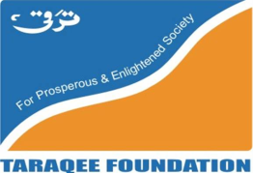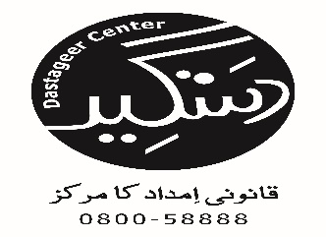

**Minutes of Meeting**

**Dastageer Legal aid Center, Quetta –Taraqee Foundation**

Minutes of the Joint Network meeting held on 10th June, 2015, at Gardenia Hotel, Quetta to share the progress update of the Dastageer Legal Aid Center (DLAC)-Taraqee Foundation, Quetta with other Rights Based Organizations (RBOs) Bar Associations, and relevant government departments. The meeting was organized to discuss and develop ways to increase & strengthen the coordination and collaboration among these organizations within the district.

**Participants of the Meeting:**

|  |  |
| --- | --- |
| Participant name | Organization |
| 1. Abdul Khaliq | Nijat Foundation |
|  |  |
| 1. Samina Nasreen | Advocate |
| 1. Shaida Muneer | Taraqee Foundation |
| 1. Aziz saddiqe | ACTS organization |
| 1. Agha Hadeer Shah | DANISH |
| 1. Rizwan Kasi | SEHER |
| 1. Shamus Ul Mulk | HRCP |
| 1. Kahir Muhammed Shaheen | Pakistan citizen Liberation Foundation |
| 1. Qamar u NIsa | Advocate |
| 1. Farzana Khilji | Quetta Bar Association |
| 1. Juma Khan Khilji | PCLF |
| 1. Amin Ullah | PCLF |
| 1. RAzzaq Baloch | TF |
| 1. Jalani Baloch | HUNNER |
| 1. MAjid Qureshi | Youth Organization |
| 1. Rafiullah | Quetta Bar Association |
| 1. Azizi Khilji | Baluchistan Bar Association |
| 1. Syed Khalid Shah | MEHEC Trust |
| 1. Malik Khuram | Insaf Net Work Pakistan |
| 1. Syed Khalil Ahmed | DLAC Quetta |
| 1. Imteyaz Hussan | DLAC Quetta |
| 1. Waheed Zaman | Society for community development |

**Agenda of the Meeting:**

**Agenda Item 1:** Progress Update by DLAC

**Agenda Item 2**: Follow-up on Action Points

**Agenda Item 3**: Recommendations for Justice Cluster/ Network

**Agenda Item 4**: Action Points for future meetings

**Proceedings/Key Discussion Points:**

**Agenda Item 1:** Progress Update by DLAC

* The meeting was postponed in Quetta for two days due to violence and target killings in the district. The participants therefore discussed the situation in terms of basic human rights in the area.
* DLAC Coordinator started the Joint Networking Meeting with welcoming the participants and explaining the agenda and purpose of the meeting.
* After the introduction of the participants a formal presentation on DLAC’s scope, services, and progress was given by the Center Coordinator.
* Malik Khurram of Insaf Network Pakistan highlighted the importance and mechanism of justice cluster. The participants appreciated the project and DLAC’s initiative and assured their full support and cooperation.
* For sustained collaboration it was recommended that network meetings should be held on monthly basis
* The participants suggested improving the referral mechanism especially with Bar Associations and relevant government departments.
* It was strongly suggested to utilize social media and print media in generating awareness.
* It was advised that member’s organization of this cluster will visit DLAC and also visit each other’s’ offices.
* The organizations pointed out that there is no minority community statistics available for the district. All participants agreed that this data needs to be available if DLAC is focused on minority issues.
* The participants unanimously agreed to develop a justice cluster and to develop its charter, ToRs and membership criteria.
* The participants voiced that even if there is a problem or an issue with the minority community they are afraid to come forward due to repercussions by the influential people of the area. They shared that a Hindu minority family was forced to migrate in an issue where influential Nawabs (feudal lords) were involved.
* It was also stressed to invite social activists and representatives of minority community in the next meeting.

**Action Points:**

|  |  |
| --- | --- |
| **Action (s) Required** | **Responsibility** |
| Finalization of Justice Group Name | DLAC Quetta |
| Finalization of Charter Of Justice and ToRs | DLAC Quetta |

Meeting ended with vote of thanks.